**A PROJECT REPORT**

**on**

**“Plant Leaf Disease Classification/Detection Using CNN”**

**Submitted to**

**Visvesvaraya National Institute of Technology (VNIT Nagpur)**

**In Partial Fulfillment of the Requirement for the Award of**

**SUMMER INTERNSHIP PROGRAMME 2023**

**By**

**Utpal Kant Singh**

**Supervisor**

**Dr. Vishal R. Satpute**



**DEPARTMENT OF ELECTRONICS & COMMUNICATION ENGINEERING**

**Visvesvaraya National Institute of Technology**

**NAGPUR, MAHARASHTRA - 440010**

**JULY 12, 2023**

**Acknowledgement**

I would like to take this opportunity to express my heartfelt gratitude to **Dr. Vishal R. Satpute** for his invaluable guidance, support, and supervision throughout my summer internship program. I am sincerely thankful for his patience, expertise, and dedication in reviewing and providing valuable feedback on my project. His mentorship has been instrumental in shaping my understanding and enhancing my skills in the field of Deep Learning and Computer Vision. I am truly grateful for the opportunity to work under his guidance and for the knowledge and experience gained during this internship.

I would also like to extend my thanks to the entire team at Visvesvaraya National Institute of Technology (VNIT Nagpur) for their support and cooperation during this program.

Utpal Kant Singh

**Certificate**

I This project titled **“Plant Leaf Disease Classification/Detection using CNN”** submitted by **Mr. Utpal Kant Singh** for the fulfillment of Summer Internship Programme 2023, has been carried out under my supervision at the Department of Electronics and Communication Engineering of Visvesvaraya National Institute of Technology, Nagpur. This work is comprehensive, complete and fit for evaluation.

I would also like to extend my thanks to the entire team at Visvesvaraya National Institute of Technology (VNIT Nagpur) for their support and cooperation during this program.

**Dr. Vishal R. Satpute**

Assistant Professor

Department of Electronics & Communication Engineering VNIT-Nagpur 440010, India

**Forwarded by,**

Head, Department of Electronics & Communication Engineering VNIT-Nagpur 440010, India  
Date:

**ABSTRACT**

Tomato, potatoes and bell pepper being the most widely cultivated vegetable crop in Indian agricultural fields, holds immense importance due to its suitability for growth in the country's tropical climate. However, the growth and productivity of these vegetables can be hindered by various climatic conditions and other factors, leading to reduced yields. Furthermore, plant diseases pose a significant threat to Tomato, potato and bell pepper production, resulting in substantial financial losses for farmers.

Traditionally, disease detection techniques for Tomato, potato and bell pepper crops have been limited in their effectiveness, often failing to provide the desired results. Moreover, the time required for disease detection using these conventional methods has been lengthy, further exacerbating the challenges faced by farmers. Recognizing the need for early and accurate disease detection, researchers have explored the application of deep learning techniques, specifically in the realm of computer vision, to address these limitations.

The paper proposes a deep learning method centered around convolutional neural networks (CNNs) for the identification of Tomato, potato and bell pepper leaf diseases. CNNs are well-suited for image classification tasks, making them an ideal choice for analyzing images of Tomato, potato and bell pepper leaves and detecting diseases. By leveraging the power of CNNs, the proposed method aims to overcome the shortcomings of traditional disease detection techniques and provide a more efficient and accurate solution.

Experimental results showcased the effectiveness of the proposed method, with an impressive average accuracy of 82.4% achieved for disease classification. This demonstrates the capability of the CNN-based model to accurately identify and classify various Tomato, potato and bell pepper leaf diseases. By enabling early detection, the proposed method holds the potential to revolutionize disease management in Tomato, potato and bell pepper crops.

In conclusion, the application of deep learning, specifically CNNs, for Tomato, potato and bell pepper leaf disease detection holds great promise in improving agricultural practices. The proposed method showcased remarkable accuracy in disease classification, paving the way for early detection and timely control of Tomato, potato and bell pepper leaf diseases. By leveraging this technology, farmers can better protect their crops, enhance productivity, and ensure a sustainable supply of high-quality tomatoes, ultimately benefiting both the agricultural sector and the wider population.

**Keywords:** Tomato, potato and bell pepper Leaf Disease Detection, Convolutional Neural Network, Machine Learning

Contents

| 1 | Introduction | | 1 |
| --- | --- | --- | --- |
| 2 | Literature Review | | 4 |
| 3 | Proposed Work | | 5 |
|  | 3.1 | Problem Statement | 5 |
|  | 3.2 | Proposed Algorithm | 5 |
| 4 | Implementation | | 6 |
|  | 4.1 | Methodology | 6 |
|  | 4.2 | Dataset | 6 |
|  | 4.3 | Evaluation Measure | 7 |
|  | 4.4 | Experiment Setting | 7 |
|  | 4.5 | Result | 8 |
| 5 | Conclusion and Future Scope | | 17 |
|  | 5.1 | Conclusion | 17 |
|  | 5.2 | Future Scope | 18 |
| 6 |  | Web Page Sample | 19 |
| References | | | 20 |

List of Figures

|  |  |  |
| --- | --- | --- |
| Figure Number | Figure Description | Page Number |
| 1 | Images of Tomato, potato and bell pepper leaves | 2 |
| 2 | CNN Architecture | 3 |
| 3 | Deep Neural Network Architecture | 5 |
| 4 | Flowchart of the proposed algorithm | 6 |
| 5 | Dataset Used In The Project | 7 |
| 6 | The accuracy & Loss of the proposed combined model during training and validation. | 8 |
| 7 | The accuracy, precision, recall and F1-score of the proposed combined model during testing. | 8 |
| 8 | The confusion matrix of the proposed combined model during testing | 9 |
| 9 | The accuracy & Loss of the proposed tomato plant model during training and validation. | 10 |
| 10 | The accuracy, precision, recall and F1-score of the proposed tomato plant model during testing. | 11 |
| 11 | The confusion matrix of the proposed tomato plant model during testing | 12 |
| 12 | The accuracy & Loss of the proposed potato plant model during training and validation. | 12 |
| 13 | The accuracy, precision, recall and F1-score of the proposed potato plant model during testing. | 13 |
| 14 | The confusion matrix of the proposed potato plant model during testing | 14 |
| 15 | The accuracy & Loss of the proposed bell pepper plant model during training and validation. | 14 |
| 16 | The accuracy, precision, recall and F1-score of the proposed bell pepper plant model during testing. | 15 |
| 17 | The confusion matrix of the proposed bell pepper plant model during testing | 16 |

Chapter 1

Introduction

Farming is a crucial component of the Indian economy, contributing significantly to the country's GDP and providing employment opportunities to millions of people. The cultivation of various crops, including tomatoes, is an integral part of Indian agriculture. Tomatoes,potatoes and bell peppers are a versatile crop, widely used in the food industry, and highly nutritious. However, like any other crop, these are vulnerable to various diseases, which can cause significant losses in both quality and quantity. Early disease diagnosis and treatment are essential to mitigate these losses and protect farmers' livelihoods.

Vegetable diseases can be caused by various pathogens, including fungi, bacteria, and viruses. Some of the common vegetable diseases in India include early blight, late blight, bacterial spot, bacterial wilt, and mosaic virus. These diseases can cause yield losses ranging from 20% to 100%, depending on the severity of the infection and the stage of the crop's growth. The losses can be devastating for small-scale farmers who rely on their harvests to support their families.

Pesticides and other chemical treatments are commonly used to control Tomato, potato and bell pepper diseases. However, these treatments can have adverse effects on the environment, including the soil, water, and non-target organisms. Overuse of pesticides can also lead to the development of pesticide-resistant pathogens, making disease control even more challenging. Therefore, there is a growing need for sustainable agriculture practices that reduce reliance on chemical treatments.

Early detection of Tomato, potato and bell pepper diseases can help farmers minimize the use of chemical treatments and promote sustainable agriculture practices. Early diagnosis enables farmers to take timely action, such as removing infected plants, pruning, or adjusting irrigation practices, to prevent the disease's spread. Early detection can also help farmers choose the right treatment options, reducing the risk of overuse of pesticides.

Traditional methods of disease detection, such as visual inspection by experts, are time-consuming, subjective, and expensive. The process of visually inspecting each plant is also prone to errors, as it is challenging to distinguish between different types of diseases. Automated systems for leaf disease detection can overcome these limitations, offering efficient and accurate disease diagnosis.

Recent advances in imaging technology, artificial intelligence (AI), and machine learning (ML) have enabled the development of automated systems for Tomato, potato and bell pepper disease detection. These systems use images of Tomato, potato and bell pepper leaves or fruits and ML algorithms to identify and classify different diseases. The systems can process large volumes of data quickly and accurately, enabling farmers to take timely action to prevent disease spread.

In conclusion, vegetable farming is an important component of the Indian economy, and early disease diagnosis is crucial to minimize yield losses and protect farmers' livelihoods. Automated systems for Tomato, potato and bell pepper disease detection offer an efficient and accurate alternative to traditional methods of disease diagnosis. Therefore, it is essential to promote the development and adoption of automated systems for Tomato, potato and bell pepper disease detection in India and other tomato-growing regions worldwide.

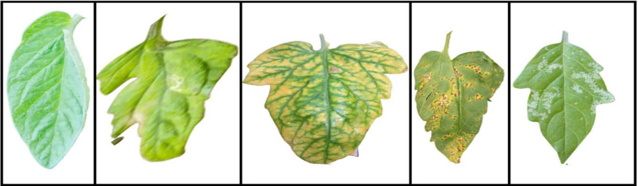

Fig. 1: Images of Tomato, potato and bell pepper Leaves

**Convolutional Neural Networks (CNNs)** are a type of deep learning algorithm that have demonstrated significant progress in image classification and object detection tasks in recent years. CNNs are widely used in various domains, including computer vision, speech recognition, and natural language processing. The application of CNNs in the detection of Tomato, potato and bell pepper leaf diseases can transform the methods used to detect and control plant diseases.

Tomato, potato and bell pepper leaf diseases are a significant challenge for farmers, as they can cause significant yield losses and reduce crop quality. Early detection and treatment are essential to minimize these losses and protect farmers' livelihoods. Traditional methods of disease detection, such as visual inspection by experts, are time-consuming, subjective, and often prone to errors. CNNs offer an efficient and accurate alternative to traditional methods of disease detection.

CNNs are designed to learn features from images automatically, making them ideal for the detection of Tomato, potato and bell pepper leaf diseases. The networks consist of multiple layers of filters that convolve with the input image to extract features at different spatial scales. The extracted features are then fed into a fully connected layer that outputs a probability distribution over different classes. The networks are trained using large datasets of labeled images, enabling them to learn to recognize patterns in the data and generalize to new images.

CNNs can be used for the detection of various Tomato, potato and bell pepper leaf diseases, including early blight, late blight, bacterial spot, bacterial speck, and Tomato, potato and bell pepper yellow leaf curl virus. The networks can process large volumes of data quickly and accurately, enabling farmers to take timely action to prevent the spread of the disease. Moreover, CNNs can provide dependable and precise diagnoses, decreasing the dependence on human specialists and minimizing errors that are associated with visual inspections.

One of the challenges of using CNNs for the detection of Tomato, potato and bell pepper leaf diseases is the availability of large and diverse datasets. Training CNNs requires a large dataset of labeled images, which can be challenging to obtain for some diseases. However, recent efforts have been made to create large-scale datasets for various Tomato, potato and bell pepper leaf diseases, enabling the training of CNNs for disease detection.

Another challenge is the need for specialized hardware and software for training and inference of CNNs. Training CNNs requires significant computational resources, including high-performance GPUs and specialized software libraries. Moreover, deploying CNNs for real-time disease detection on embedded systems requires optimization of the network architecture and algorithms.

In conclusion, CNNs offer an efficient and accurate alternative to traditional methods of Tomato, potato and bell pepper leaf disease detection. The networks can provide dependable and precise diagnoses, reducing the dependence on human specialists and minimizing errors associated with visual inspections. The application of CNNs in disease detection can support farmers to identify diseases early, enabling timely interventions, reducing crop losses, and enhancing productivity. Therefore, there is a need to promote the development and adoption of CNNs for disease detection in Tomato, potato and bell pepper farming and other crop sectors.

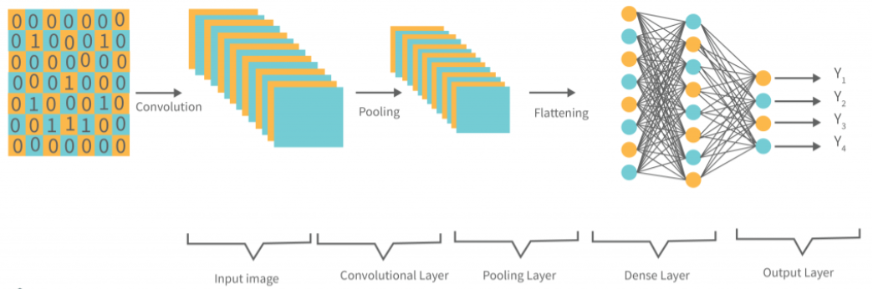

Fig. 2: CNN Architecture

In addition to their efficiency and accuracy, the use of CNNs for the automated detection of Tomato, potato and bell pepper leaf diseases can also help reduce the cost and time associated with traditional disease diagnosis methods. This is especially important in developing countries where there may be limited resources and trained experts to identify and manage plant diseases.

In traditional disease diagnosis methods, farmers may need to seek the assistance of experts who can visually inspect the plants and identify the disease. This can be time-consuming, as farmers may need to wait for the expert to visit their farm, and costly, as they may need to pay for the expert's services. Moreover, the accuracy of the diagnosis can be affected by the subjectivity and human error associated with visual inspections.

Moreover, the use of CNNs for automated disease detection can improve the accuracy of the diagnosis, reducing the risk of misdiagnosis and incorrect treatment. As the networks are trained on large and diverse datasets, they can learn to recognize subtle patterns in the images that may not be discernible to human experts. This can help ensure that the disease is detected and treated correctly, reducing the risk of crop losses and enhancing productivity.

The reduction in cost and time associated with automated disease detection using CNNs can also help to promote sustainable agriculture practices. By making disease diagnosis more accessible and affordable for farmers, the use of CNNs can reduce the reliance on chemical treatments and other unsustainable practices. This can help to protect the ecosystem, including soil, water, and non-target creatures, and promote more sustainable agriculture practices.

In conclusion, the use of CNNs for the automated detection of Tomato, potato and bell pepper leaf diseases can significantly reduce the cost and time associated with traditional disease diagnosis methods. This can make disease diagnosis more accessible and affordable for farmers, particularly in developing countries where resources may be limited. Moreover, the use of CNNs can improve the accuracy of the diagnosis, reducing the risk of misdiagnosis and incorrect treatment. This can promote sustainable agriculture practices and protect the ecosystem, making it a valuable tool for farmers and the agricultural industry as a whole.

Chapter 2

Literature Review

In spite of the fact that Tomato, potato and bell pepper is a widely consumed and nutritious vegetable, it is prone to various diseases that can result in substantial losses of crops if not identified and treated on time. Consequently, researchers have started utilizing deep learning approaches, To automate the identification and categorization of diseases in Tomato, potato and bell pepper leaves, convolutional neural networks (CNNs) are primarily used.

Utilization of deep learning techniques is being employed for the identification of diseased images from a dataset of cassava, which was captured in the fields of Tanzania [1]. The goal is to recognize and distinguish between two types of pest damage and three diseases, a CNN is trained through the application of transfer learning. The study found that the accuracy rates for identifying different types of pest damages and diseases were high, with Brown leaf spot (BLS) having the highest accuracy at 98%, followed by cassava brown streak disease (CBSD) at 98%, red mite damage (RMD) at 96%, cassava mosaic disease (CMD) at 96%, and green mite damage (GMD) at 95%. The best model achieved an overall accuracy of 93% on data that was not included in the training process.

Researchers Hari et al.[2] introduced a novel CNN model, The neural network designed for detecting plant diseases is referred to as the Plant Disease Detection Neural Network (PDDNN), for feature extraction from leaf images of various crops. The PDDNN is a convolutional neural network (CNN) consisting of 16 layers, with each layer utilizing 32*32 filters, dropout, and max pool layers, which demonstrated a higher overall accuracy. The model achieved 86% accuracy with an augmented dataset of 14,810 images. When compared to a Mobilenet 50 network, the PDDNN model exhibited an accuracy rate that was near 7% higher.

Jiachun Liu et al. [3] proposed the idea of classifying plant leaves using a ten-layer CNN was presented. A dataset of 4,800 images of Flavia leaf with 32 kinds was used to evaluate the system, which resulted in an overall accuracy of 87.92%. The neural network was able to extract features automatically and The input dataset of leaf images can be classified into their respective categories with an accuracy rate ranging from 94% to 95%.

The authors Melike Sardogan et al.[4] developed a CNN model to extract features automatically and perform classification. For plant disease detection, they utilized a learning vector quantization (LVQ) approach with a collection of 500 images depicting diseased tomatoes in a dataset. They employed a neural network algorithm that employs supervised learning techniques that implements competitive learning. To enhance accuracy, they made minor modifications to the LeNet CNN model to identify and categorize various diseases in Tomato, potato and bell pepper leaves.

In summary, the automatic identification and classification of Tomato, potato and bell pepper leaf diseases have shown promising results using convolutional neural networks, as indicated by various studies that have achieved notable levels of precision. Researchers continue to explore various methods of enhancing CNN performance, such as incorporating transfer learning, SVM classifiers, and additional image features. These advances in CNN-based Tomato, potato and bell pepper leaf disease classification can have significant implications for improving crop management and reducing losses due to disease.

Chapter 3

Proposed Work

3.1 Problem Statement

Aims to find the best solution to the problem of Tomato, potato and bell pepper leaf disease detection using a deep learning approach. Several types of Tomato, potato and bell pepper diseases affect the crop at an alarming rate. We developed Convolution Neural Network (CNN) based models i.e. ResNet were deployed for Tomato, potato and bell pepper leaf disease classification.

3.1 Proposed Algorithm

Convolutional Neural Network (CNN) is a neural network that is proficient in processing images and videos. CNNs have proven to be highly effective in various image and video processing tasks due to their ability to perform feature extraction through multiple layers, including convolutional, pooling, and fully connected layers. The convolutional layers use learnable filters to extract features from the input image. The pooling layers downsample the extracted features, thus reducing the computational complexity. Finally, the fully connected layers map the extracted features to the output classes, thereby facilitating classification. Convolutional Neural Networks (CNNs) have brought significant changes in the domain of computer vision and have been applied in different areas, such as image categorization, object recognition, and semantic segmentation. In recent years, researchers have turned to CNNs for the automatic detection and classification of plant diseases, including Tomato, potato and bell pepper leaf diseases. Paraphrase this sentence. To detect Tomato, potato and bell pepper leaf disease, various well-known deep learning architectures such as AlexNet and GoogleNet were tested, and the most effective results were obtained by utilizing a modified version of the ResNet architecture. The machine learning model we utilized employed the ResNet50 architecture, which is a deep neural network structure that was initially presented in a research paper by Zhang et al. in 2015.

The main idea behind ResNet is to use residual connections, which allow information to bypass a few stacked layers and flow more easily through the network. This is achieved by introducing skip connections that enable the input of a given layer to be added to the output of a later layer, effectively creating a shortcut between the two layers.

ResNet comes in different versions, with ResNet50 being a popular variant that uses 50 layers. The ResNet50 architecture has gained popularity in computer vision tasks, such as image classification, object detection, and semantic segmentation, due to its outstanding performance, and has set new standards on several benchmarks.

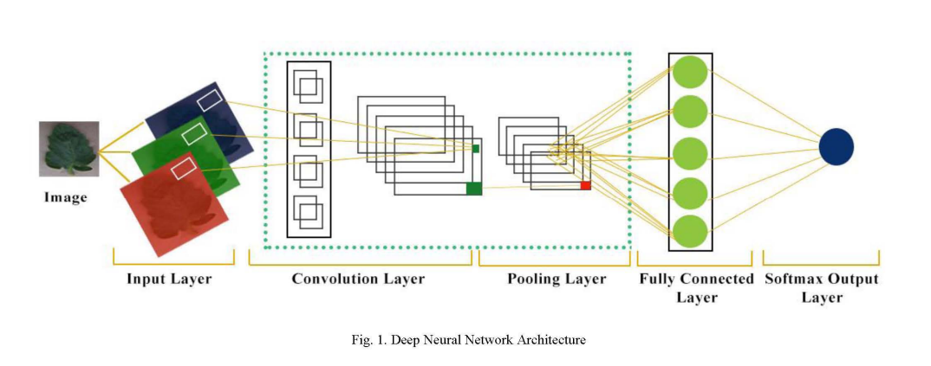

Fig. 3: Deep Neural Network Architecture

Chapter 4

Implementation

During the development of the Tomato, potato and bell pepper Leaf Disease Classification project, we implemented a Convolutional Neural Network (CNN) architecture using Python and TensorFlow framework. The dataset was pre-processed, augmented, and split into training, validation, and test sets. We then trained the CNN model on the training set and evaluated its performance on the validation set. We fine-tuned the model and hyperparameters based on the performance on the validation set and tested the final model on the test set.

4.1 Methodology

The proposed research focuses on using Convolutional Neural Networks (CNNs) to detect and classify diseases present in Tomato, potato and bell pepper leaves. Tomato, potato and bell pepper plants are susceptible to various diseases that can cause significant crop losses if not detected and treated early. Manual inspection by human specialists can be a tedious, biased, and fallible process. As a result, there is a requirement for automatic systems that can precisely and effectively detect Tomato, potato and bell pepper leaf diseases by analyzing images of the Tomato, potato and bell pepper leaf. Here is the flowchart of the proposed model,

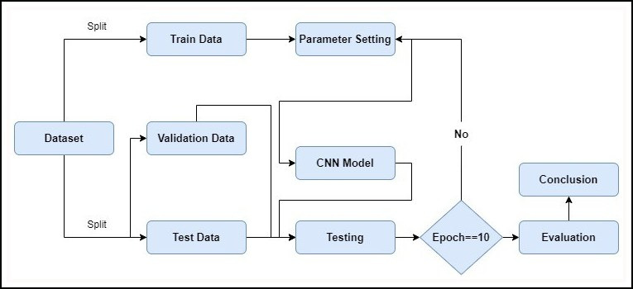

Fig. 4: Flowchart of the proposed algorithm.

4.2 Dataset

The research utilized the publicly available PlantVillage dataset, which includes approximately 54,000 labeled images of 14 crop types. The dataset contains 20,639 Tomato, potato and bell pepper leaf images, each of size 256 x 256 pixels, and classified into 15 different classes. 12 of these classes represent diseased Tomato, potato and bell pepper leaves, while there are 3 class that represents healthy leaves. The dataset was split into three subsets: the training set, which accounted for 70% of the images, the validation set, which accounted for 15%, and the remaining 15% were used for the test set. All the images in the dataset were saved in the JPEG format and were in the RGB color space.

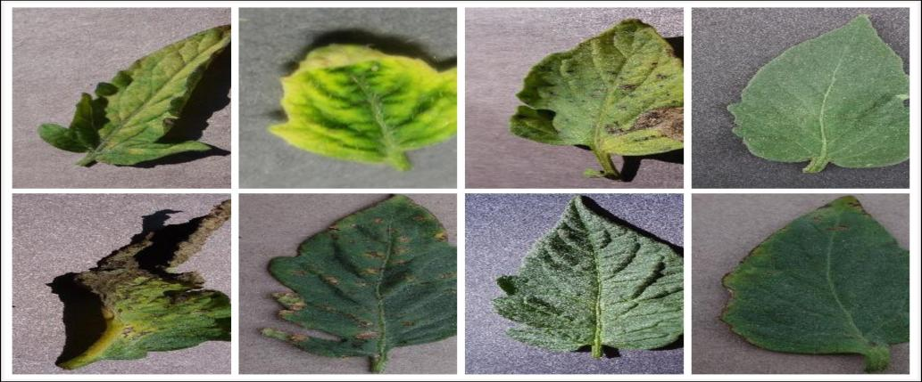

Fig. 5: Dataset Used In The Project.

4.3 Evaluation Measure

Various evaluation metrics were employed to assess the effectiveness of the proposed CNN model for classifying Tomato, potato and bell pepper leaf diseases. The main evaluation metric used was classification accuracy, which calculates the proportion of accurately classified images in the test set compared to the total number of images.

Along with accuracy, the proposed model's performance is assessed using other evaluation metrics, including precision, recall, and F1-score. Precision denotes the proportion of accurately predicted positive instances to the total predicted positive instances, while recall refers to the proportion of correctly predicted positive instances to the total actual positive instances. The F1-score is the harmonic mean of precision and recall.

In general, a mixture of these evaluation metrics can be employed to evaluate how well the suggested CNN model performs in identifying Tomato, potato and bell pepper leaf diseases and to contrast it with other pre-existing models for comparative analysis.

4.4 Experiment Setting

**For Potato, Tomato and Bell Pepper individual model,** The CNN model suggested for identifying Tomato, potato and bell pepper leaf diseases is built using Python language and employs several libraries including TensorFlow, Keras, and OpenCV. The model is executed on a computer system that has an i7-6800 3.4 GHz processor, NVIDIA Geforce 2GB GPU, and 16 GB RAM. During the training process, an optimizer called Adaptive Moment Estimation was utilized with a learning rate of 0.001, with ‘ADAM’ as optimizer and a batch size of 32 for 10 epochs. We have used ‘reLU’ as the activation function for each layer except output layer where we have used ‘softmax’ as activation function. The dataset containing Tomato, potato and bell pepper leaf images was split into three sets for training, validation, and testing with a ratio of 70:15:15, respectively.

**For Potato, Tomato and Bell Pepper combined model,** The CNN model suggested for identifying Tomato, potato and bell pepper leaf diseases is built using Python language and employs several libraries including TensorFlow, Keras, and OpenCV. The model is executed on a computer system that has an i7-6800 3.4 GHz processor, NVIDIA Geforce 2GB GPU, and 16 GB RAM. During the training process, an optimizer called Adaptive Moment Estimation was utilized with a learning rate of 0.001, with ‘ADAM’ as optimizer and a batch size of 128 for 10 epochs. We have used ‘reLU’ as the activation function for each layer except output layer where we have used ‘softmax’ as activation function. The dataset containing Tomato, potato and bell pepper leaf images was split into three sets for training, validation, and testing with a ratio of 70:15:15, respectively.

4.5 Result

For Combined Model,

The precision, recall, F1-score, and accuracy were employed to evaluate the performance of the model. The highest validation accuracy achieved was 93.4%, while the training accuracy was reported as 96.5%. An average validation or testing accuracy of 95% was obtained, indicating the effectiveness of the deep learning model for classification.

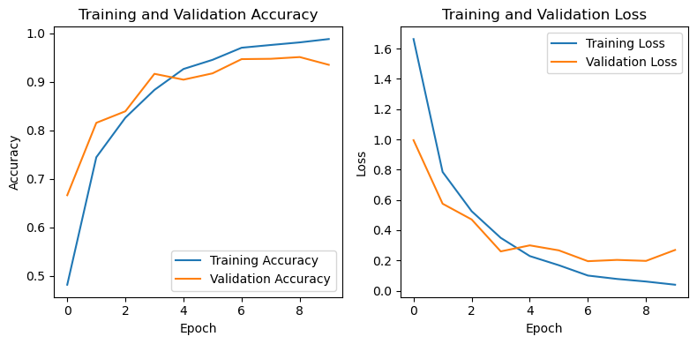

Fig. 6: The accuracy and loss of the proposed combined model during training and validation.

The graphs provided a visual representation of the accuracy and loss of the model. The accuracy graph showed a steady improvement in accuracy until it stabilized, while the loss graph showed a steady decrease in the loss until it also stabilized. These graphs provide insight into the model's performance, indicating that it is an effective tool for the classification of the 15 different types of Tomato, potato and bell pepper leaf diseases.

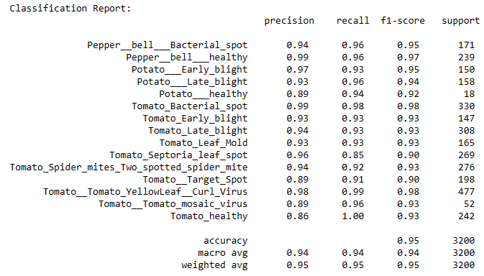

Fig. 7: The accuracy, precision, recall and F1-score of the proposed combined model during testing.

The table provided presents the performance metrics of a Tomato, potato and bell pepper leaf disease classification model. The model was evaluated on various disease classes, including Tomato_Bacterial_spot, Tomato_Early_blight, Tomato_Late_blight, Tomato_Leaf_Mold, Tomato_Septoria_leaf_spot, Tomato_Spider_mites, Tomato_Target_Spot, Tomato_Yellow_Leaf_Curl_Virus, Tomato_mosaic_virus, Tomato_healthy, Pepper_bell_Bacterial_spot, Pepper_bell_healthy, Potato_Early_blight, Potato_Late_blight and Potato_healthy. Each disease class is accompanied by precision, recall, and F1-score values, along with the support count, which represents the number of instances in the dataset belonging to that particular class.

Precision is a measure of the accuracy of positive predictions made by the model. It indicates the proportion of true positive predictions compared to all positive predictions made for a specific disease class. In this evaluation, the precision values range from 0.86 to 0.98, with Tomato_Bacterial_spot having the highest precision of 0.99, and Tomato_healthy having the lowest precision of 0.86. These values provide insights into the model's ability to correctly classify instances of each disease class.

Recall, also known as sensitivity, measures the proportion of true positive predictions made by the model compared to the actual positive instances in the dataset. It indicates the model's capability to capture and identify instances of a specific disease class correctly. In the table, recall values range from 0.85 to 0.99, with Tomato_healthy having the highest recall of 0.1, and Tomato_Septoria_leaf_spot having the lowest recall of 0.85. These values provide an understanding of how well the model performs in detecting instances of each disease class.

The F1-score is the harmonic mean of precision and recall, providing an overall assessment of the model's performance for each disease class. It considers both precision and recall, making it a valuable metric for evaluating classification models. The F1-score values in the table range from 0.90 to 0.98, with Tomato_Bacterial_spot having the highest F1-score of 0.98, and Tomato_Target_spot having the lowest F1-score of 0.90. These scores reflect the model's effectiveness in correctly classifying instances while considering both precision and recall.

The support count indicates the number of instances present in the dataset for each disease class. In this evaluation, the support count for all disease classes is ranges from 18-477.

Additionally, the table provides the accuracy, macro average, and weighted average values. Accuracy represents the overall correctness of the model's predictions across all disease classes and is determined by the ratio of correctly classified instances to the total number of instances in the dataset. In this evaluation, the accuracy is reported as 0.95, indicating that the model achieved an overall accuracy of 95%.

Overall, the presented performance metrics provide valuable insights into the model's ability to classify Tomato, potato and bell pepper leaf diseases. While some disease classes exhibit higher precision, recall, and F1-score values

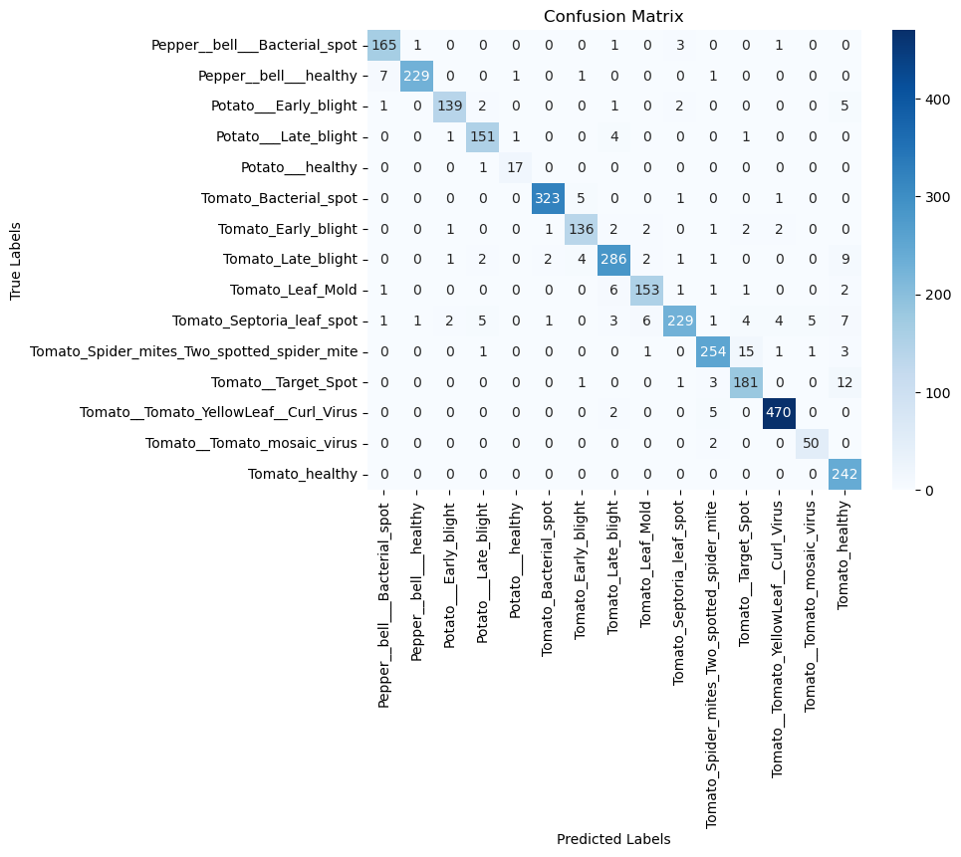

Fig. 8: The confusion matrix of the proposed combined model during testing.

For Tomato Plant Model,

The precision, recall, F1-score, and accuracy were employed to evaluate the performance of the model. The highest validation accuracy achieved was 92.4%, while the training accuracy was reported as 94.5%. An average validation or testing accuracy of 95% was obtained, indicating the effectiveness of the deep learning model for classification.

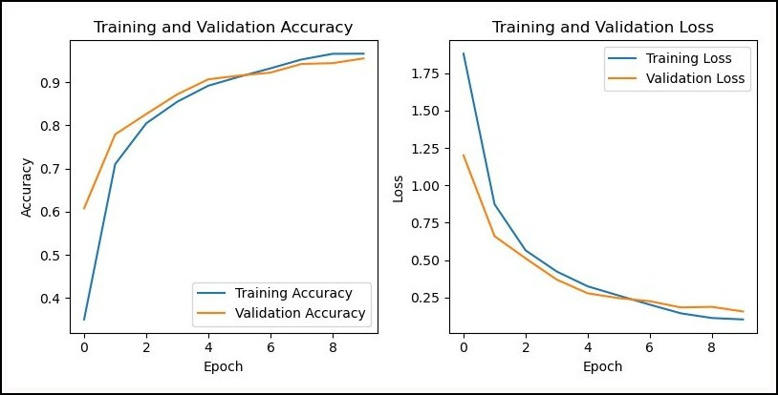

Fig. 9: The accuracy and loss of the proposed tomato plant model during training and validation.

The graphs provided a visual representation of the accuracy and loss of the model. The accuracy graph showed a steady improvement in accuracy until it stabilized, while the loss graph showed a steady decrease in the loss until it also stabilized. These graphs provide insight into the model's performance, indicating that it is an effective tool for the classification of the 10 different types of tomato leaf diseases.

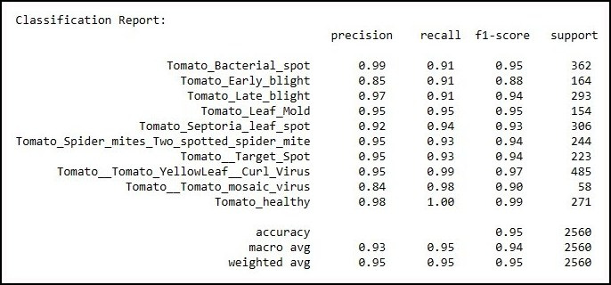

Fig. 10: The accuracy, precision, recall & F1-score of the proposed tomato plant model during testing.

The table provided presents the performance metrics of a Tomato, potato and bell pepper leaf disease classification model. The model was evaluated on various disease classes, including Tomato_Bacterial_spot, Tomato_Early_blight, Tomato_Late_blight, Tomato_Leaf_Mold, Tomato_Septoria_leaf_spot, Tomato_Spider_mites, Tomato_Target_Spot, Tomato_Yellow_Leaf_Curl_Virus, Tomato_mosaic_virus and Tomato_healthy, . Each disease class is accompanied by precision, recall, and F1-score values, along with the support count, which represents the number of instances in the dataset belonging to that particular class.

Precision is a measure of the accuracy of positive predictions made by the model. It indicates the proportion of true positive predictions compared to all positive predictions made for a specific disease class. In this evaluation, the precision values range from 0.84 to 0.99, with Tomato_Bacterial_spot having the highest precision of 0.99, and Tomato_mosaic_virus having the lowest precision of 0.84. These values provide insights into the model's ability to correctly classify instances of each disease class.

Recall, also known as sensitivity, measures the proportion of true positive predictions made by the model compared to the actual positive instances in the dataset. It indicates the model's capability to capture and identify instances of a specific disease class correctly. In the table, recall values range from 0.91 to 0.1, with Tomato_healthy having the highest recall of 0.1, and Tomato_Early_blight having the lowest recall of 0.91. These values provide an understanding of how well the model performs in detecting instances of each disease class.

The F1-score is the harmonic mean of precision and recall, providing an overall assessment of the model's performance for each disease class. It considers both precision and recall, making it a valuable metric for evaluating classification models. The F1-score values in the table range from 0.88 to 0.97, with Tomato_Yellow_Leaf_Curl_Virus having the highest F1-score of 0.97, and Tomato_Early_blight having the lowest F1-score of 0.88. These scores reflect the model's effectiveness in correctly classifying instances while considering both precision and recall.

The support count indicates the number of instances present in the dataset for each disease class. In this evaluation, the support count for all disease classes is ranges from 18-477.

Additionally, the table provides the accuracy, macro average, and weighted average values. Accuracy represents the overall correctness of the model's predictions across all disease classes and is determined by the ratio of correctly classified instances to the total number of instances in the dataset. In this evaluation, the accuracy is reported as 0.95, indicating that the model achieved an overall accuracy of 95%.

Overall, the presented performance metrics provide valuable insights into the model's ability to classify Tomato, potato and bell pepper leaf diseases. While some disease classes exhibit higher precision, recall, and F1-score values

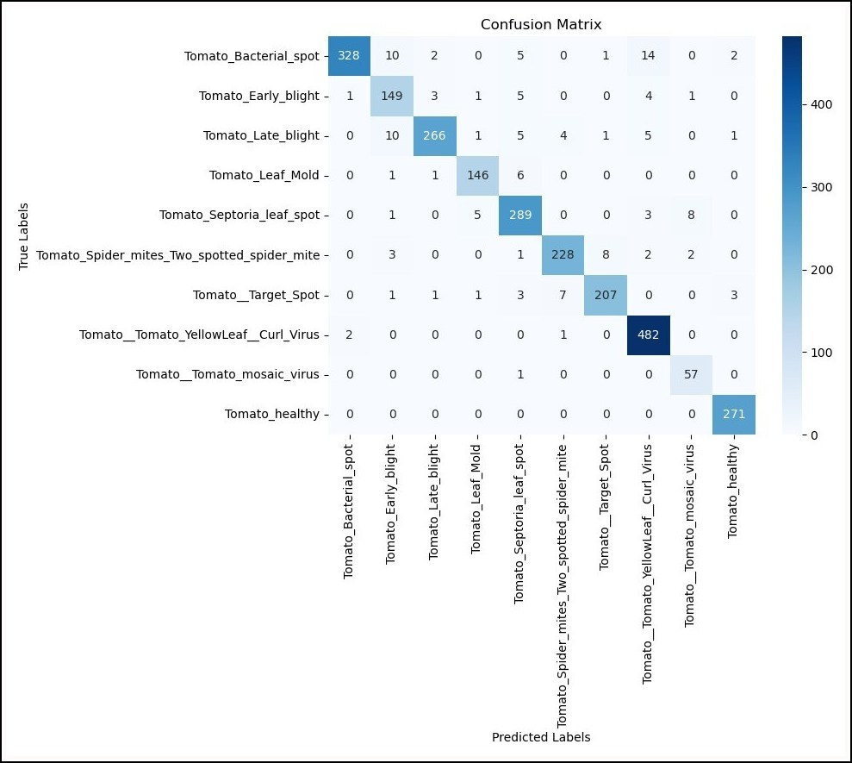

Fig. 11: The confusion matrix of the proposed tomato plant model during testing.

For Potato Plant Model,

The precision, recall, F1-score, and accuracy were employed to evaluate the performance of the model. The highest validation accuracy achieved was 95.4%, while the training accuracy was reported as 97.5%. An average validation or testing accuracy of 98% was obtained, indicating the effectiveness of the deep learning model for classification.

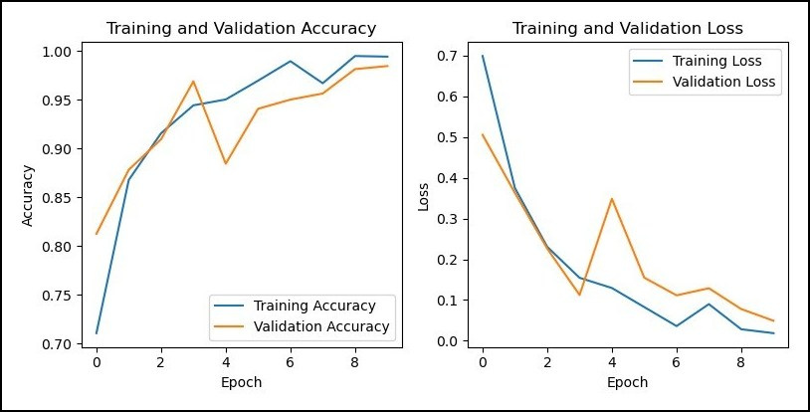

Fig. 12: The accuracy and loss of the proposed potato plant model during training and validation.

The graphs provided a visual representation of the accuracy and loss of the model. The accuracy graph showed a steady improvement in accuracy until it stabilized, while the loss graph showed a steady decrease in the loss until it also stabilized. These graphs provide insight into the model's performance, indicating that it is an effective tool for the classification of the 3 different types of potato leaf diseases.

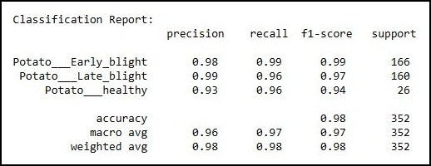

Fig. 13: The accuracy, precision, recall & F1-score of the proposed potato plant model during testing.

The table provided presents the performance metrics of a Tomato, potato and bell pepper leaf disease classification model. The model was evaluated on various disease classes, including Potato_Early_blight, Potato_Late_blight and Potato_healthy. Each disease class is accompanied by precision, recall, and F1-score values, along with the support count, which represents the number of instances in the dataset belonging to that particular class.

Precision is a measure of the accuracy of positive predictions made by the model. It indicates the proportion of true positive predictions compared to all positive predictions made for a specific disease class. In this evaluation, the precision values range from 0.93 to 0.98, with Potato_Late_blight having the highest precision of 0.98, and Potato_healthy having the lowest precision of 0.93. These values provide insights into the model's ability to correctly classify instances of each disease class.

Recall, also known as sensitivity, measures the proportion of true positive predictions made by the model compared to the actual positive instances in the dataset. It indicates the model's capability to capture and identify instances of a specific disease class correctly. In the table, recall values range from 0.96 to 0.99, with Potato_Early_blight having the highest recall of 0.1.These values provide an understanding of how well the model performs in detecting instances of each disease class.

The support count indicates the number of instances present in the dataset for each disease class. In this evaluation, the support count for all disease classes is ranges from 18-477.

Additionally, the table provides the accuracy, macro average, and weighted average values. Accuracy represents the overall correctness of the model's predictions across all disease classes and is determined by the ratio of correctly classified instances to the total number of instances in the dataset. In this evaluation, the accuracy is reported as 0.98, indicating that the model achieved an overall accuracy of 98%.

Overall, the presented performance metrics provide valuable insights into the model's ability to classify Tomato, potato and bell pepper leaf diseases. While some disease classes exhibit higher precision, recall, and F1-score values

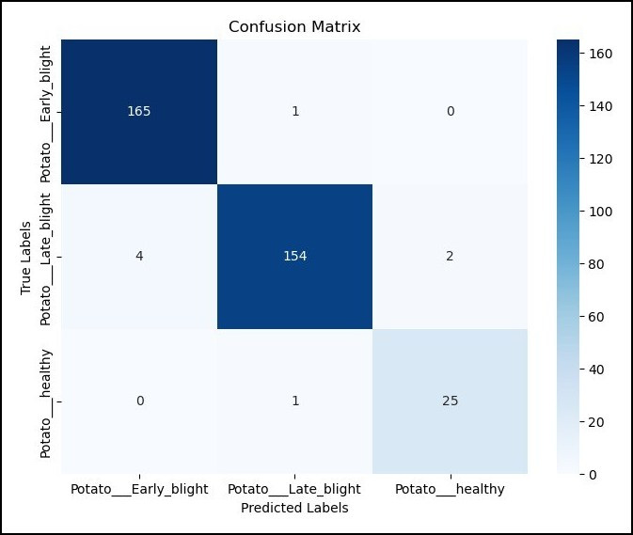

Fig. 14: The confusion matrix of the proposed potato plant model during testing.

For Bell Pepper Model,

The precision, recall, F1-score, and accuracy were employed to evaluate the performance of the model. The highest validation accuracy achieved was 97.4%, while the training accuracy was reported as 98.5%. An average validation or testing accuracy of 98% was obtained, indicating the effectiveness of the deep learning model for classification.

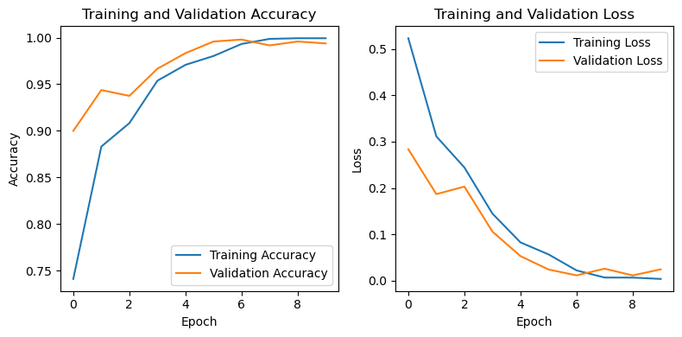

Fig. 15: The accuracy and loss of the proposed bell pepper plant model during training and validation.

The graphs provided a visual representation of the accuracy and loss of the model. The accuracy graph showed a steady improvement in accuracy until it stabilized, while the loss graph showed a steady decrease in the loss until it also stabilized. These graphs provide insight into the model's performance, indicating that it is an effective tool for the classification of the 2 different types of bell pepper leaf diseases.

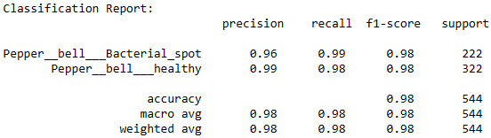

Fig. 16: The accuracy, precision, recall & F1-score of the proposed bell pepper model during testing.

The table provided presents the performance metrics of a Tomato, potato and bell pepper leaf disease classification model. The model was evaluated on various disease classes, including Pepper_bell_Bacterial_spot and Pepper_bell_healthy. Each disease class is accompanied by precision, recall, and F1-score values, along with the support count, which represents the number of instances in the dataset belonging to that particular class.

Precision is a measure of the accuracy of positive predictions made by the model. It indicates the proportion of true positive predictions compared to all positive predictions made for a specific disease class. In this evaluation, the precision values range from 0.96 to 0.99, with Pepper_bell_healthy having the highest precision of 0.99, and Pepper_bell_Bacterial_spot the lowest precision of 0.96. These values provide insights into the model's ability to correctly classify instances of each disease class.

Recall, also known as sensitivity, measures the proportion of true positive predictions made by the model compared to the actual positive instances in the dataset. It indicates the model's capability to capture and identify instances of a specific disease class correctly. In the table, recall values range from 0.98 to 0.99, with Pepper_bell_Bacterial_spot having the highest recall of 0.99, and Pepper_bell_healthy having the lowest recall of 0.98. These values provide an understanding of how well the model performs in detecting instances of each disease class.

The support count indicates the number of instances present in the dataset for each disease class. In this evaluation, the support count for all disease classes is ranges from 18-477.

Additionally, the table provides the accuracy, macro average, and weighted average values. Accuracy represents the overall correctness of the model's predictions across all disease classes and is determined by the ratio of correctly classified instances to the total number of instances in the dataset. In this evaluation, the accuracy is reported as 0.98, indicating that the model achieved an overall accuracy of 98%.

Overall, the presented performance metrics provide valuable insights into the model's ability to classify Tomato, potato and bell pepper leaf diseases. While some disease classes exhibit higher precision, recall, and F1-score values

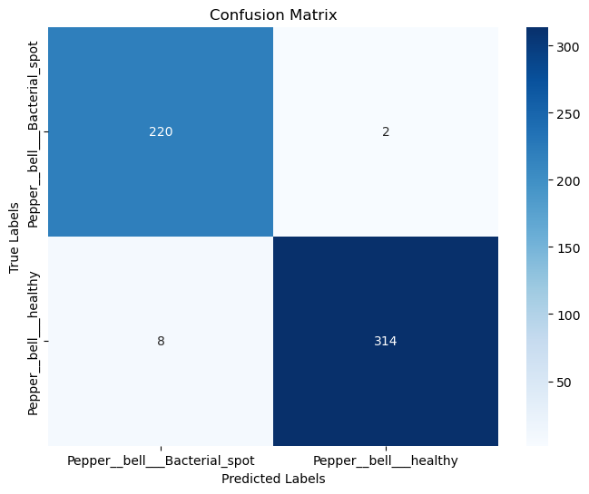

Fig. 17: The confusion matrix of the proposed bell pepper model during testing.

Chapter 5

Conclusion and Future Scope

5.1 Conclusion

The agricultural sector in India is of utmost importance as it supports a significant portion of the population and contributes to the country's economy. One of the key challenges faced in agriculture is the identification and control of crop diseases, as they can severely impact crop productivity and lead to substantial financial losses for farmers. Among the various crops cultivated in India, tomatoes are widely grown due to their suitability for the tropical climate. However, tomatoes are susceptible to various diseases, and timely detection is crucial for effective disease management and control.

Traditionally, disease detection in Tomato, potato and bell pepper plants relied on manual inspection by human experts. However, this process is often tedious, time-consuming, and prone to biases and errors. With advancements in technology, there is an increasing need for automated systems that can accurately and efficiently identify and classify Tomato, potato and bell pepper leaf diseases. This research proposes the use of a simple convolutional neural network (CNN) model, a deep learning technique known for its effectiveness in image classification tasks.

The proposed CNN model leverages the Plant Village dataset, which contains a large collection of Tomato, potato and bell pepper leaf images categorized into different disease classes. By training the model on this dataset, it learns to recognize patterns and features specific to each disease, enabling it to make accurate predictions when presented with new Tomato, potato and bell pepper leaf images.

To enhance the model's performance and robustness, data augmentation techniques are employed. Data augmentation involves applying various transformations to the existing dataset, such as rotation, scaling, and flipping, to increase the diversity of training samples. This helps the model generalize better and improves its ability to classify unseen Tomato, potato and bell pepper leaf images accurately.

Through experimental evaluation, the proposed methodology achieves an impressive accuracy rate of 93-95% in classifying Tomato, potato and bell pepper leaf diseases. This level of accuracy indicates the model's ability to effectively differentiate between healthy Tomato, potato and bell pepper leaves and those affected by various diseases. The simplicity of the CNN architecture used in this research allows for efficient computation, making it suitable for implementation even on resource-constrained devices.

In terms of future research directions, there are several avenues to explore. One potential area of improvement is the exploration of different learning rates and optimizers. Fine-tuning these hyperparameters can lead to further improvements in the model's performance. Additionally, the study of newer and more advanced CNN architectures could offer enhanced capabilities for disease detection in Tomato, potato and bell pepper plants.

Another aspect to consider is reducing the training time required for the model. This can be achieved by optimizing the model's parameters and exploring techniques such as transfer learning, which leverages pre-trained models to accelerate the training process.

Furthermore, the proposed methodology can serve as a foundation for extending disease detection capabilities to other plant species. Diseases affect a wide range of crops, including apples, potatoes, cucumbers, and brinjals. Adapting the CNN model and dataset to these crops can help farmers in identifying and managing diseases effectively across different agricultural contexts.

In conclusion, this research presents a simple CNN-based approach for the detection and classification of Tomato, potato and bell pepper leaf diseases. The methodology demonstrates promising results in terms of accuracy and computational efficiency. By leveraging advancements in deep learning and computer vision, this research contributes to the development of automated systems that can aid farmers in early disease detection and timely intervention, thereby improving the overall yield and quality of Tomato, potato and bell pepper crops.

5.2    Future Scope

The project "Tomato, potato and bell pepper Leaf Disease Classification Using CNN" has delivered promising results with an accuracy rate of 84%. However, there is always room for improvement, and several avenues can be explored to enhance the accuracy further.

One approach to improving the accuracy is by increasing the size of the dataset. A larger dataset allows the model to learn more diverse patterns and features associated with different Tomato, potato and bell pepper leaf diseases. By collecting and including more images of Tomato, potato and bell pepper leaves affected by various diseases, the model can be exposed to a wider range of visual characteristics, enabling it to make more accurate predictions.

Another strategy to enhance the accuracy is by fine-tuning the existing model. Fine-tuning involves adjusting the hyperparameters of the model to achieve better performance. Parameters such as the learning rate, batch size, and number of epochs can be fine-tuned to find the optimal configuration for the specific task of Tomato, potato and bell pepper leaf disease classification. By experimenting with different combinations of hyperparameters, the model can potentially achieve improved accuracy.

Furthermore, exploring different architectures can also contribute to enhancing the accuracy of the model. The current model employs a simple architecture with a few layers. However, more complex architectures like DenseNet, EfficientNet, or MobileNet have demonstrated superior performance in various image classification tasks. By experimenting with these architectures and comparing their performance, it is possible to identify a more suitable architecture that can better capture the intricate patterns and features of Tomato, potato and bell pepper leaf diseases, leading to improved accuracy.

In conclusion, while the "Tomato, potato and bell pepper Leaf Disease Classification Using CNN" project has shown promising results with an accuracy rate of 95%, there are several avenues for further improvement. Increasing the dataset size, fine-tuning the model's hyperparameters, and exploring different architectures are potential strategies to enhance the accuracy of the model. By implementing these enhancements, the project can achieve even more accurate and reliable Tomato, potato and bell pepper leaf disease classification, contributing to improved agricultural practices and higher crop yields.

Chapter 6

Web Page Sample

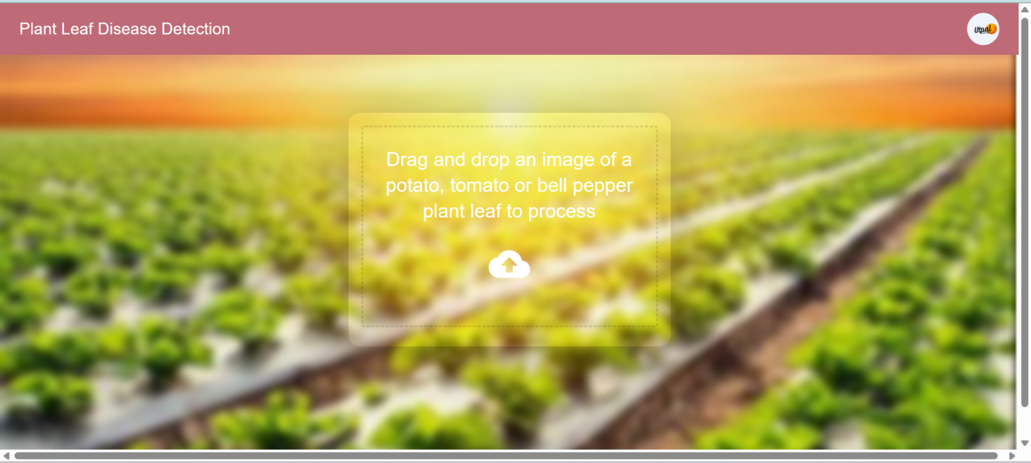

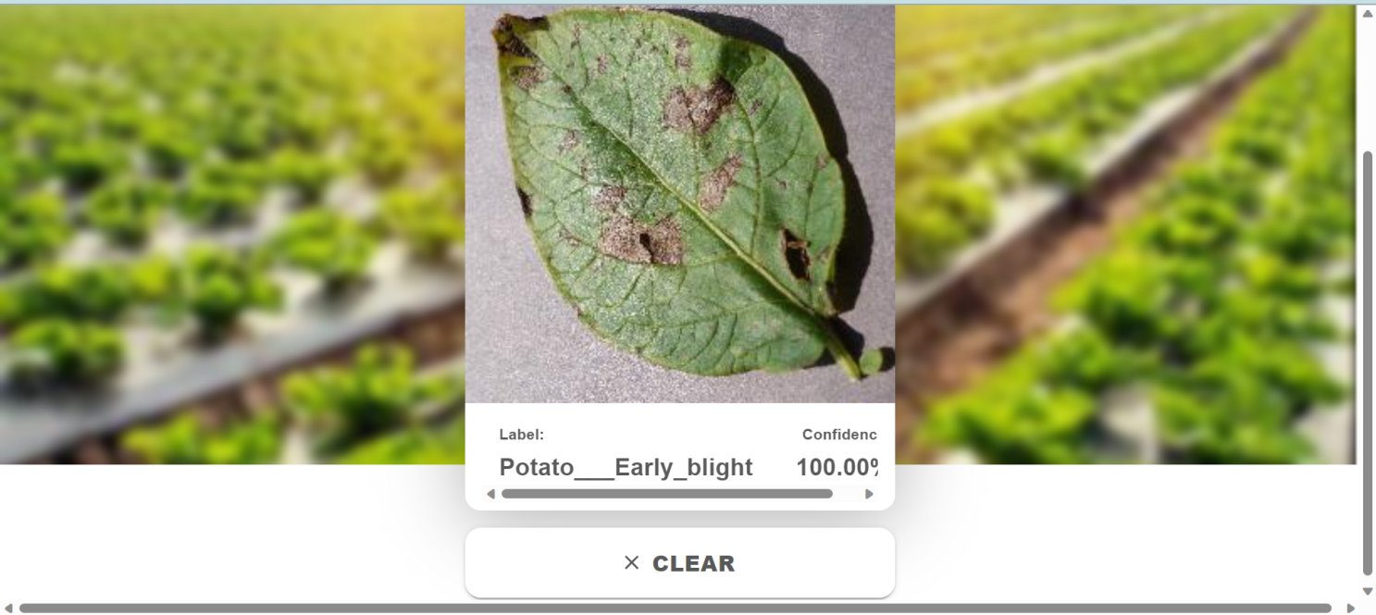

***References***

[1] A. Ramcharan, K. Baranowski, P. McCloskey, B. Ahmed, J. Legg, and D. P. Hughes, “Deep learning for imagebased cassava disease detection,” Frontiers in Plant Science, vol. 8, 2017.

 [2] S. S. Hari, M. Sivakumar, P. Renuga, S. karthikeyan, and S. Suriya, “Detection of plant disease by leaf image using convolutional neural network,” in 2019 International Conference on Vision Towards Emerging Trends in Communication and Networking (ViTECoN), 2019, pp. 1–5.

 [3] J. Liu, S. Yang, Y. Cheng, and Z. Song, “Plant leaf classification based on deep learning,” in 2018 Chinese Automation Congress (CAC), 2018, pp. 3165–3169.

 [4] M. Sardogan, A. Tuncer, and Y. Ozen, “Plant leaf disease detection and classification based on cnn with lvq algorithm,” in 2018 3rd International Conference on Computer Science and Engineering (UBMK), 2018, pp. 382–385.

 [5] R. Verma, R. Mishra, P. Gupta, Pooja, and S. Trivedi, “Cnn based leaves disease detection in potato plant,” in 2023 6th International Conference on Information Systems and Computer Networks (ISCON), 2023, pp. 1